Feniscowles Primary School
Reading Policy


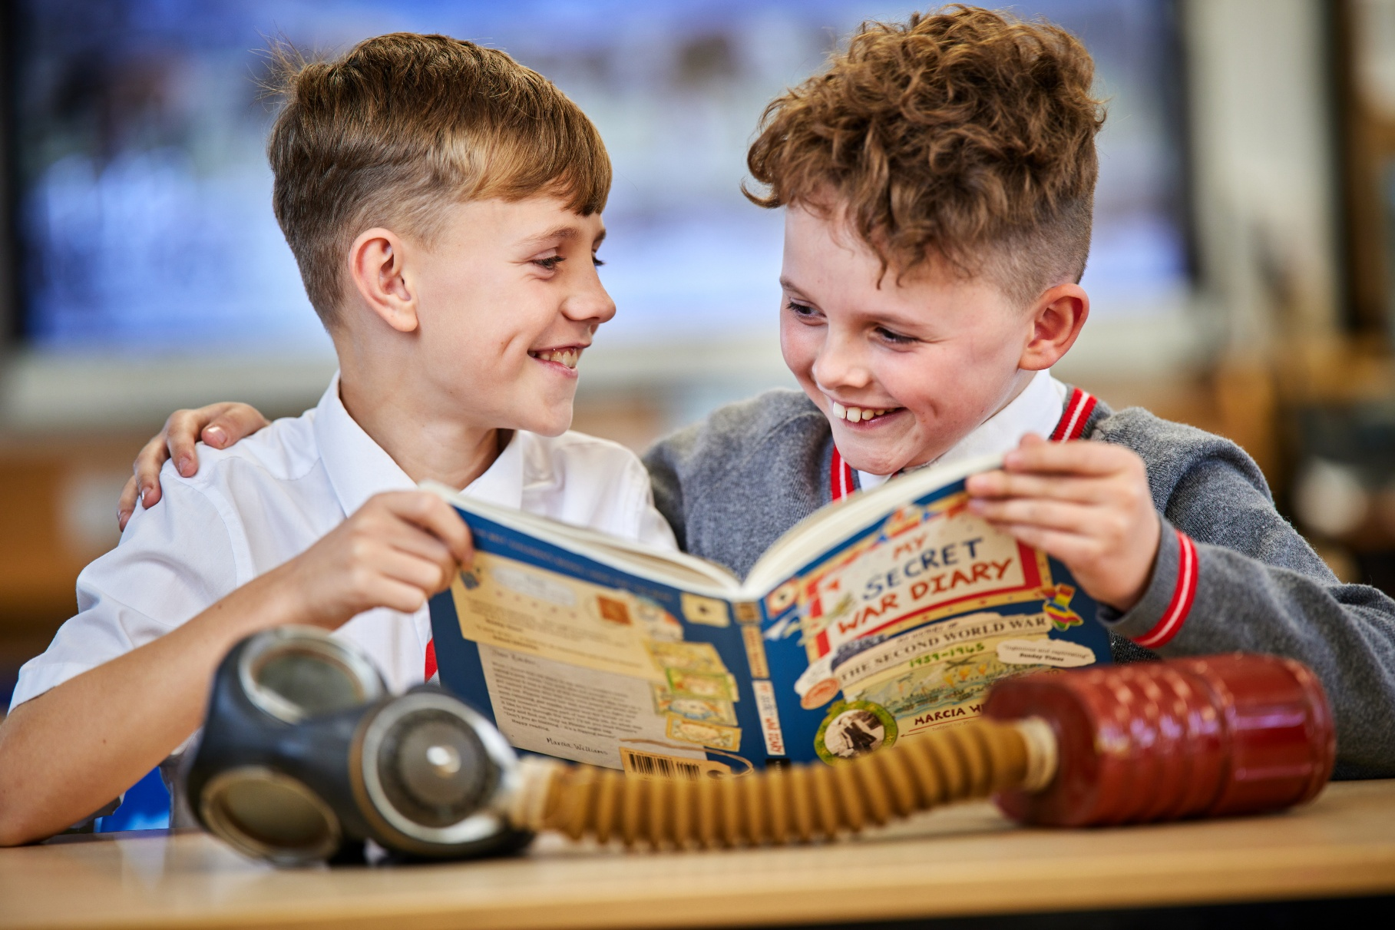

How does English reading contribute to our curriculum intent?

Statement of Intent

The English curriculum at Feniscowles Primary School has been shaped by the principles outlined in the National Curriculum and we aim to provide a high-quality English education which develops children’s ability to listen, speak, read and write for a wide range of purposes and audiences. As a school, we are continually ‘striving for excellence’ and therefore we see the National Curriculum as forming only the starting point in the pursuit of our goal of allowing the Feniscowles Child to live life to its fullest. We have high aspirations for all our children and it is essential that, by the end of their primary education, all pupils are able to read fluently and with confidence, in any subject in their forthcoming secondary education.

With our learners’ starting points and the rise of digital media in mind, we recognise that speaking, listening and language acquisition is paramount to ensuring that our children access the whole curriculum effectively. We strive to be good role models as we interact with pupils and value quality dialogue so that our children have the oracy skills to communicate with confidence and respond appropriately to different audiences, in both formal and informal contexts.

We recognise that reading is an essential life skill and will enable children to embrace the opportunities that life brings. We strive to teach our learners the key skills to be able to read, as well as a passion and love for books and reading. Through our commitment to the delivery of excellence in the teaching of systematic, synthetic Phonics, we ensure that pupils gain the knowledge and skills to become confident, fluent readers with the ability to use a range of reading strategies and skills. Please refer to our ‘Phonics Policy’ which can be found on our website for further detail relating specifically to the systematic teaching of Phonics.

At Feniscowles Primary School, the journey of literature begins as soon as our learners enter our school. Our EYFS curriculum is text-rich and forms the beginning of our reading pathway. Across each year group, our texts are carefully selected to ensure that the values that define our culture and ethos, shaping the Feniscowles Child are reflected. The texts are regularly reviewed to ensure that our children are exposed to the best of new literature.
We prioritise reading for both enjoyment and purpose in all year groups. Children are enabled to express themselves creatively and imaginatively as they become enthusiastic and critical readers of stories, non-fiction texts and poetry as well as media texts too. The use of quality texts across the wider curriculum further supports children’s understanding of questioning, language and builds up a purposeful and meaningful vocabulary. This helps to develop children’s understanding of concepts and knowledge in other areas of learning. In addition to this, we feel passionately that our children should be exposed to literary greats simply because they are influential in terms of literature, particularly as the cultural capital of our learners varies. Overall, we aim to develop a culture of reading in which children become readers rather than children who read.
In addition, we recognise the value of memorable experiences in nurturing love and knowledge with regards to the English language. In summary, we aspire to deliver a rich and varied curriculum that enables pupils to develop into confident, literate and articulate members of the community who have a positive impact on the world around them.

Implementation

Here at Feniscowles, we have designed an exciting Reading curriculum in which knowledge, understanding and skills are progressively built. A text-based approach is used to deliver content within a meaningful context and strong links are made across other curriculum areas. This helps to enhance communication, language and literacy across the curriculum by fostering a deeper understanding of vocabulary and allowing our children to transfer knowledge and language across curriculum areas.

At Feniscowles Primary School, our bespoke Reading curriculum focuses and consists of three dimensions:
- Word reading
- Comprehension
- Reading for Pleasure

Our literature spine has been carefully chosen to ensure that the high-quality texts our children study include a range of fiction, non-fiction and poetry. As our learners have varying levels of cultural capital, with large gaps in some areas, background knowledge and vocabulary are both taught explicitly within our reading lessons to aid children’s reading comprehension.

In order to teach all our pupils to become fluent, confident readers, who have a love of reading, we deliver quality systematic Phonics teaching from EYFS until the end of KS1 (following the Little Wandle programme). From Year 3 upwards we teach whole class guided reading daily through the Ready Steady Read Together Programme. Within these sessions, children are taught the skills of reading and strategies needed to become competent readers; Ready Steady Read Together gives every pupil access to high-quality texts, enabling them to experience literature that develops fluency, vocabulary and understanding. Through teacher modelling of expression, pace, intonation and prosody, children learn how skilled readers bring meaning to a text and how these features support comprehension. Shared reading also creates opportunities for discussion, questioning, drama and exploration of language, which deepen comprehension whilst enhancing oracy skills. Crucially, it ensures that every child, regardless of their decoding ability, can engage with ambitious texts and develop the habit of reading widely and often for both pleasure and learning.

Organisation and Curriculum Coverage
Ready Steady Read Together units are built around engaging, vocabulary-rich texts and provide a wealth of opportunities for reading, discussion and metacognition. Each unit follows a clear sequence of learning episodes, supports vocabulary development in context and includes structured opportunities for retrieval, fluency and strategy modelling and discussion. Progression is actively embedded within teaching to build comprehension skills, word reading, understanding of terminology and knowledge of the content domains step by step, ensuring consistency and clarity across the year groups.
Management and Staff Development
All staff have received specific Ready Steady Read Together training and the principles of successful implementation are applied consistently across the school. The English Subject Lead draws on the programme’s leadership materials to monitor, review and evaluate strengths and identify next steps. We also ensure that the environment supports shared reading, provides scaffolding for all children to succeed and fosters a positive reading culture. Five explicit Ready Steady Read Together lessons are delivered each week, each lasting 30 minutes. Information from the Teacher Reading Audit, Pupil Voice and other leadership documentation is used to identify further CPD needs and is reviewed regularly to maintain staff confidence in delivering the highest quality shared reading lessons.
Resources and Planning
Each class has specific Ready Steady Read Together vehicle texts with suggested supplementary books to support the themes and encourage reading for pleasure. Lesson plans, resources and leadership guidance are provided through the online membership homepage. Teaching is supported with structured questions and answers that enable teachers to model, scaffold and extend pupils’ understanding so that all children can access and engage with texts effectively. The shared reading curriculum is mapped through the Progression Overview documents and units include all resources required to deliver dynamic and inclusive lessons.

Assessment
Teachers use daily formative assessment through observation, questioning and feedback to stretch and challenge pupils and to identify those who need additional support. A checklist at the bottom of the Pupil Practise and Apply booklet allows teachers to indicate specific areas of difficulty. In addition to this feedback, a low-stakes quiz is completed in the fifth lesson each week, giving children the opportunity to apply the strategies and skills they have been developing. Throughout the academic year, three assessments are carried out in each year group, supported by Excel breakdowns that enable gap analysis. The data highlights strengths and weaknesses across the content domains. By identifying next steps, the tool helps teachers and leaders target teaching and explicitly model the required skills and strategies in subsequent lessons. Subject leaders analyse termly data and address areas for development. Attainment, progress and barriers to learning are reviewed in termly pupil progress meetings, where clear actions are agreed to close gaps, particularly for pupils in the bottom 20%.

Inclusion
‘If you get it right for the most disadvantaged and vulnerable, you get it right for everyone.’ (Sir Martyn Oliver, His Majesty’s Chief Inspector at the Office for Standards in Education, Children’s Services and Skills, March 2025).
Ready Steady Read Together is aspirational for every child. It ensures that all pupils, including those with barriers such as dyslexia who may struggle with fluency and independent reading, are given opportunities to develop their comprehension of challenging texts with scaffolded support. Children who face language barriers, such as those with English as an additional language, benefit from accurate English modelling, peer collaboration, dual coding, scaffolded speaking and listening activities and the use of technology to aid comprehension. For pupils with special educational needs, the programme provides guidance and advice through suggested intervention, scaffolds and breakdown strategies. Confident readers are encouraged to deepen their understanding, explore a wide range of literature and develop higher-order thinking, with units adapted to provide additional challenge where appropriate. Optional activities are also suggested, making Ready Steady Read Together a highly valued resource within our school that enriches teaching, supports inclusion and raises the profile of reading across the whole community.
Reading for Pleasure
At Feniscowles, reading for pleasure is highly valued and actively promoted throughout the school day. We recognise that regular exposure to high-quality texts supports children’s language development, comprehension skills and fosters a lifelong love of reading. In EYFS, story time is a key part of the daily routine. Children are read to regularly, with adults modelling enjoyment of stories, introducing rich vocabulary and encouraging discussion around texts.
In Key Stage 1, children are read to frequently by adults. A range of engaging and age-appropriate texts are shared to develop listening skills, comprehension and a positive attitude towards reading.
In Key Stage 2, children take part in 15 minutes of daily reading. This may take the form of silent independent reading or listening to an adult read a class text. This time is used to promote reading stamina, enjoyment and exposure to a wide range of authors and genres.

Book Talk
Book talk is an integral part of our approach to reading and reading for pleasure at Feniscowles Primary School. Through structured and purposeful discussion about texts, children are supported to articulate their ideas, deepen their understanding and engage critically with what they read.

In KS1, book talk is embedded within the Little Wandle reading sessions, where children regularly discuss texts with adults and peers. These discussions support comprehension, vocabulary development and confidence in expressing opinions about books.

In KS2, book talk is a key component of Ready Steady Read Together lessons. Each lesson includes a dedicated section for book talk, allowing children to explore themes, characters, language choices and author’s intent. This structures discussion supports comprehension, promotes engagement with a wide range of texts and helps develop thoughtful, reflective readers.

Home Reading

From their earliest starting points at Feniscowles, our children are encouraged to develop good home-school reading routines in order to consolidate reading progress and involve parents/carers in their own child’s reading. Each week in EYFS, KS1 and KS2, children visit our library and spend time browsing, discussing and selecting a book from our wide selection with an adult. Parents/carers at home are encouraged to read these stories to children as part of a bedtime story routine. We also encourage parents/carers to access e-books at the stage their child is working within via the Oxford Owl online library. It is expected that all children will read to an adult at least three times a week at home and have their reading record signed. Children in EYFS and KS1 take home reading books closely matched to their Phonics knowledge and reading ability. Our early reading scheme aligns closely with our synthetic Phonics programme of Little Wandle.
Time is dedicated to hearing/’teaching’ children read on a 1:1 basis frequently by an adult in school, especially in EYFS and KS1, until their confidence, fluency and understanding has been developed. In KS2, children requiring additional practice continue to read on a 1:1 basis or in a guided reading group.

Impact
The impact of our English curriculum is measured through the monitoring cycle in school alongside our assessment procedures. This includes:
- Lesson observations
- Book monitoring
- Learning walks
- Discussions with class teachers
- Discussions with pupils
- Formative and summative assessment data, including regular analysis and evaluation by class teachers and subject leaders
Monitoring and assessment data is used to measure whether:
- Learners enjoy and are inspired by the reading curriculum in our school.
- There is a clear progression of learners’ work and teachers’ expectations in our school.
- Learners’ work shows a range of texts are explored and a range of reading skills are being taught effectively.
- Learners are able to express their views on the books, authors and genres they are reading and are able to read for pleasure.
- Feedback from teachers has an impact on our pupils, often with next step questions to push learning on.
- All learners are making progress with their reading, including EAL and SEND learners.
- Pupils are able to use the knowledge and skills learnt to meet the challenges of the next part of their educational journey and to do so with confidence.
Recording of Work
We aim to ensure that pupils develop a range of skills of response. Pupils are able to process and record their responses after discussion in writing, talk and other creative modes. Adult scribing is also used and added to the Working Wall so that it can be referred back to.

Involving Parents and Carers (Co-Curriculum)

At Feniscowles Primary School, we believe that parents/carers have a vital role to play in supporting children with their reading skill development. We encourage parents/carers to be involved in the reading curriculum by:
- Providing parents/carers with guides outlining what the expectations for
reading are in EYFS, KS1 and KS2 and how they can support their child at home.
- Inviting parents/carers to attend parents’ evenings twice a year to discuss their child’s progress and development.
- Ensuring that class teachers regularly communicate with parents/carers with regards to progress in Reading and reading at home.
- Using our English page on the school website to provide information and useful resources for parents/carers.

Early Years Foundation Stage (EYFS)

At Feniscowles Primary School, children in EYFS are immersed in Phonics from the very beginning of their journey in order to develop the skills required for accurate word reading. We recognise the vital link between the development of communication and language skills and reading. This prime area of the EYFS curriculum underpins all of our early years learning and we believe that this is paramount for developing life-long readers. Working within small groups and individually, practitioners model quality vocabulary in order to enable children to access a variety of texts and the wider curriculum. A range of texts and genres have been carefully selected to ensure that our children are exposed to a rich variety of literature beyond the children’s current reading ability and allowing us to make purposeful cross-curricular links. There is also the freedom for children to develop their own reading interests and practitioners have the flexibility to incorporate these interests within their lesson planning. High-quality stories, poetry, rhymes, songs and information is shared with the children daily and children are motivated to talk and re-enact their encounters with texts during child-initiated play. During Little Wandle sessions, children are encouraged to develop positive early reading behaviours, Phonics teaching is reinforced and careful questioning is linked to the foundation stage curriculum. Teachers prepare for story reading so that they can capture the children’s attention and imagination. This involves dramatization with the children and repetition, helping children to develop expressive language skills. In EYFS we recognise that the environment plays a key role in supporting the children’s reading development. We aim to create attractive, welcoming and stimulating learning areas, both inside and outside the classroom, which are rich with texts, encouraging children to explore and select books independently. Children feel safe, secure and confident to read for pleasure during independent learning time. From their earliest starting points, children are excited about reading and we feel this creates a strong foundation for a life-long love of reading.

Role of the Subject Leader
The English leader is responsible for:
- Ensuring continuity and progression in knowledge and skills across year groups from EYFS to Year 6
- Acting as a model of good practice and provide targeted support and guidance to staff
- Monitoring and evaluating the quality of teaching and learning in reading regularly and improving the standards of reading throughout school
- Analysing assessment data in order to plan whole school improvement in reading
- Working with senior leaders to develop the ongoing training and staff development activities to ensure staff have the skills and confidence to deliver high quality teaching
- Keeping up to date on national initiatives links to English and undertaking research into best practice
- Keeping the school’s policy for reading under regular review
Training, support for staff and connected experts

Regular CPD is provided in line with the school’s overall curriculum development cycle. Where further support is required, the subject leader provides bespoke 1:1 support. Collaborative work has also been undertaken with an English Consultant who has supported staff in the development of effective teaching and learning.

