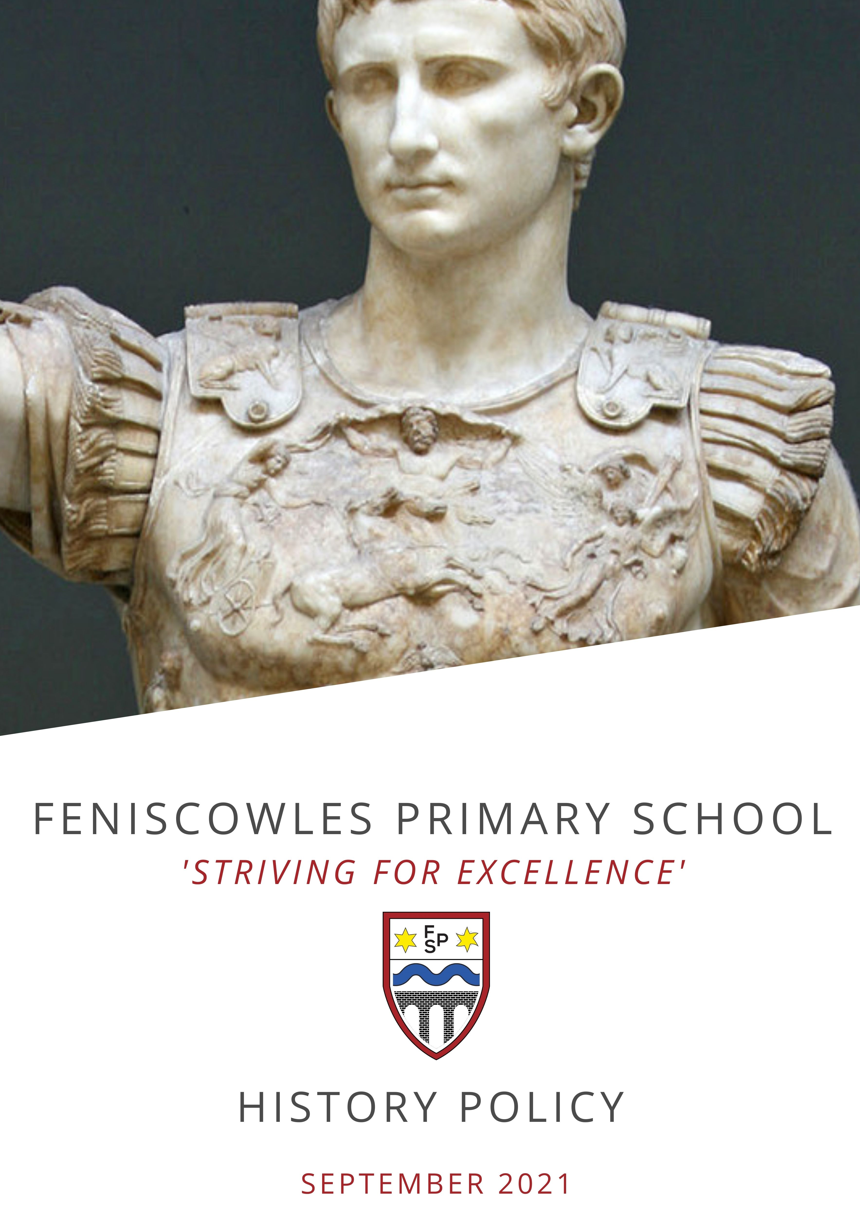

Contents
Revisions 3
Context 3
Statement of Intent 4
Implementation 5
Time Allocation 8
Learning organisers 8
Impact 8
Recording of work 9
Assessment, Reporting and Tracking Progress 9
SEND, Disadvantaged and Greater Depth 9
Safeguarding 10
The Learning Environment 10
Involving Parents and Carers (Co-Curriculum) 10
Training, support for staff and connected experts 10

Revisions
Written by: R. Clarkson
Date : 24th November 2025
Review date:

Revision 2:

Context
The national curriculum for history aims to ensure that all pupils:
- know and understand the history of these islands as a coherent, chronological narrative, from the earliest times to the present day: how people’s lives have shaped this nation and how Britain has influenced and been influenced by the wider world
- know and understand significant aspects of the history of the wider world: the nature of ancient civilisations; the expansion and dissolution of empires; characteristic features of past non-European societies; achievements and follies of mankind
- gain and deploy a historically grounded understanding of abstract terms such as ‘empire’, ‘civilisation’, ‘parliament’ and ‘peasantry’
- understand historical concepts such as continuity and change, cause and consequence, similarity, difference and significance, and use them to make connections, draw contrasts, analyse trends, frame historically-valid questions and create their own structured accounts, including written narratives and analyses
- understand the methods of historical enquiry, including how evidence is used rigorously to make historical claims, and discern how and why contrasting arguments and interpretations of the past have been constructed
- gain historical perspective by placing their growing knowledge into different contexts, understanding the connections between local, regional, national and international history; between cultural, economic, military, political, religious and social history; and between short- and long-term timescales.
We have taken on board the findings published into effective teaching of History.
https://www.gov.uk/government/publications/research-review-series-history/research-review-series-history
Our curriculum design and structure has been considered and will be reviewed with these findings and recommendations in mind.
We believe that our curriculum design and structure is well matched to these principles.

Statement of Intent
Feniscowles Primary School has created a curriculum intent statement. This intent has been written to provide an overarching context for our school curriculum to allow ‘A Feniscowles Child’ to ‘Live Life in its fullest’. This document can be found on our website and should be read in conjunction with our subject specific intent statements.
The study of history at Feniscowles Primary School has been developed with our school motto of ‘Striving for Excellence’ as its guiding principle. The National Curriculum provides schools with a clear program of study for us to follow.
At Feniscowles Primary School we see this as the starting point for our own individualised curriculum to meet the needs of our learners and to support them in their development as a Feniscowles child. Our curriculum has been carefully shaped to give our children a coherent knowledge and understanding of Britain’s past and that of the wider world; a knowledge and understanding of the development of Feniscowles and Blackburn with Darwen, celebrating in the local achievements of the past that continue to influence the world today; a chance to develop into agile learners, encouraging their curiosity and pride as well as giving opportunities to enhance their cultural capital.
History at Feniscowles involves engaging pupils in investigating questions about people and events in the past in order to enable them to better understand their lives today and for a future as more informed and enlightened citizens. This is essential for our children to successfully navigate the challenges they may face in a VUCA (Volatile, Uncertain, Complex, Ambiguous) world and for them to seek and maximise the wonderful opportunities available to them. This is essential for our children to successfully navigate the challenges they may face in a VUCA (Volatile, Uncertain, Complex, Ambiguous) world and for them to seek and maximise the wonderful opportunities available to them.
Our enquiry approach and high expectations develop their knowledge and understanding of key vocabulary which is revisited and then built on throughout the Key Stages. In this subject, the children will learn and remember more facts and knowledge. They will have the opportunity to excel with that knowledge when following their enquiries. Through the study of history, pupils also develop a wide range of critical thinking skills, which enable them to understand the contested nature of knowledge and to distinguish between ‘fact’ and subjectivity when it comes to reaching conclusions and making judgements about the past. We aim to give our children a positive and aspirational future where they can see a place for talent, skill and endeavour within their home town, making links between achievements in the past and opportunities for their futures. Across our year-groups, our units have been carefully linked to those of other subjects to enhance children’s immersion and understanding. Within each unit, opportunities to identify the values that define our culture and ethos, shaping The Feniscowles’ Child: endeavour, integrity, respect, safety, compassion and forgiveness are carefully identified. With this in mind we have established a school curriculum plan for history as an entitlement for all pupils that is:
Aspirational in terms of instilling in our pupils a desire to achieve the highest levels of success through providing them with the opportunities to excel in terms of their acquisition of long-lasting knowledge and understanding and mastery of core historical skills. Such high aspirations are clearly identifiable in the progressive and increasingly challenging objectives of the scheme of work of each enquiry, which define clearly what the pupils will know, understand and be able to do;
Logical, and broad and balanced in terms of the areas of subject content we have selected which reflect the guidance and the demands of the National Curriculum. For example, we have ensured that content includes representative investigations of British history spanning the period from the Stone Age to the Norman invasion of 1066 as well as enquiries focusing on the achievements of ancient civilizations such as the Shang Dynasty and Ancient Greece;
Chronologically sequenced as pupils progress through the school which allows them opportunities to evaluate both change and progress from one historical period to another and to build on previous knowledge and understanding as they tackle more complex and demanding enquiries;
Relevant in terms of the careful consideration that has been given to the selection of historical enquiries that extend the knowledge and understanding of pupils beyond 1066 e.g., evaluating the significance of the Volunteer Army within the defeat of Nazi Germany;
Progressively more challenging Years 1 through 6 both in terms of the complexity of the subject knowledge we want our pupils to acquire and also the critical thinking skills we support them to utilise to ensure they understand the significance of that knowledge. These anticipated outcomes in knowledge and understanding and skills acquisition are detailed in the objectives of the detailed scheme of work for each enquiry.
Built upon and has continuity with the provision for history established in the Early Years Foundation Stage and in particular that which addresses the knowledge and skills expectations of the Past and Present Early Learning Goal;
Inclusive in terms of delivering the same curriculum to all of our pupils irrespective of specific learning needs or disabilities and differentiating where necessary through, for example, in class support, providing different learning environments, alternative learning activities and assessment outcomes.

Implementation
In EYFS children secure a strong grounding in their ‘Understanding of the World’, before entering formal History teaching in Y1. We have chosen to approach our teaching through an enquiry approach, which we believe best suits our overarching curriculum intent. Our EYFS history curriculum prepares children for the Key Stage 1 National Curriculum history requirements.
At Feniscowles, we continue our enquiry approach in Years 1 to 6, using elements from the Collins Connected History but with the addition of bespoke Heritage Units which celebrate the rich history of the areas of Feniscowles, Blackburn with Darwen and the closely related coastal area of the Fylde Coast. This approach to learning and teaching in history develops our pupils as young historians.
Through enquiry, our pupils not only build subject knowledge and understanding but become increasingly adept at critical thinking, the use of specialised vocabulary and their grasp of subject concepts.
We structure learning in history through big question-led enquiries about relevant historical topics, places and themes. Our curriculum is therefore ‘knowledge rich’ rather than content heavy as we recognise that if we attempt to teach historical topics, places, themes and issues in their entirety we restrict opportunities for pupils to master and apply critical thinking skills and achieve more challenging subject outcomes.
We adopt a policy of immersive learning in history that provides sufficient time and space for our pupils not only to acquire new knowledge and subject vocabulary but also to develop subject concepts and understand the significance of what they have learned.
Where there are local connections to the adopted Collins units, we use these to further immerse the children in that historical period; for example, making use of local experts at Blackburn Museum, visiting Corporation Park, Ribchester (Roman fort) and the Cuerdale Hoard (Viking treasure).
Our learning and teaching in history is interactive and practical allowing opportunities for pupils to work independently, in pairs and also in groups of various sizes both inside and outside of the classroom. Wherever possible, we provide our pupils with contemporaneous historical evidence including narratives, paintings, photographs, artefacts, and data in the form of censuses and films to analyse and from which to reach conclusions and make judgements. Similarly, we provide varied and differentiated ways for pupils to record the outcomes of their work including the use of PowerPoint, concept mapping, annotated diagrams, improvised drama and the application of a wide range of writing genres. Only in this way will knowledge become embedded and ‘sticky’ and ensure that our pupils can build on what they know and understand from one year to the next.
The schemes of work for each historical enquiry highlight both the objectives and anticipated outcomes of the investigation. They are also carefully structured through the use of ancillary questions, to enable pupils to build their knowledge and understanding in incremental steps of increasing complexity until they reach the point where they are able to answer the question posed at the beginning of the investigation. Our learning and teaching in history also recognises the importance of the local area with a number of our investigations involving observation, recording, presentation, interpretation and the evaluation of historical information outside of the classroom e.g., significant people, places and events locally.

Reception
Autumn | Growing up
Autumn | Remembrance
Spring | Coco Chanel – Person of significance.
Summer | Castles
Year 1
Autumn | How do our toys and games compare to those of children in the 1960s?
Spring | Who was Matthew Henson?
Summer | Local Heritage Unit: Why is Corporation Park such an important place?
Year 2
Autumn | What does it take to be a great explorer?
Spring | How do we know so much about what happened in the Great Fire of London?
Summer | Local Heritage Unit: Why does Blackpool have a tower?
Year 3
Autumn | How did the life of Ancient Britons change during the Stone Age?
Spring | How did living in the Bronze Age compare with life in the Iron Age?
Summer | Local Heritage Unit: Why was Feniscowles once world famous for making long elephants?
Year 4
Autumn | How did the arrival of the Romans change Britain?
Spring | Who were the Anglo-Saxons and how do we know what was important to them?
Summer | What did the Vikings want and how did Alfred help to stop them getting it?
Year 5
Autumn | How did a pile of dragon bones help to solve an ancient Chinese mystery?
Spring | The story of the Trojan Horse: historical fact, legend or classical myth?
Summer | Local Heritage Unit: Why is Blackburn such a historically important place to live?
Year 6
Autumn 1 | How did the largest volunteer army in the world help Britain defeat Nazi Germany?
Autumn 2 | How have the medical breakthroughs of the last two hundred and fifty years affected the lives of people in Britain?
Summer 2 | What was life like in Baghdad during the Golden Age of Islam?

Please also read in conjunction with our module overviews which are available on our school website. These overviews offer the detail and set out curriculum progression in terms of both the substantive and disciplinary knowledge that the children gain in each unit of work.

Time Allocation
In EYFS, History is taught through a balance of whole class teaching and continuous provision, within the ‘Understanding the World’ specific area of the EYFS Framework. This is carefully aligned to the work completed with National Curriculum year groups, providing effective starting points as learners build knowledge, skills and understanding over time.
In National Curriculum year groups, History is taught weekly with a unit for a half-term and three units per academic year. This is for one hour depending on the context of the module, but is often greater to allow for more challenging enquiries.

Learning organisers
Learning organisers are used throughout school to support children understanding key concepts alongside learning key knowledge and vocabulary. These organisers are not a ‘to learn list’, but a supportive tool to allow children to make connections in learning and be supported in demonstrating key historical understanding.

Impact
Each enquiry, which forms our programme of learning and teaching in history, sets clear objectives and outcomes for the pupil in terms of knowledge and understanding and skills acquisition. The schemes of work also suggest a range of ways in which the teacher can assess whether a pupil has achieved these outcomes.
We ensure that when assessing pupils, evidence is drawn from a wide range of sources to inform the process, including interaction with pupils during discussions and related questioning, day to day observations, practical activities such as model making and role play drama, the gathering, presentation and communication of fieldwork data and writing in different genres. The outcomes of each enquiry serve to inform the teacher’s developing picture of the knowledge and understanding of each pupil and to plan future learning accordingly. We do not make summative judgements about individual pieces of pupil work but rather use such outcomes to build an emerging picture of what the pupil knows, understands and can do.
At the end of each year, we make a summative judgement about the achievement of each pupil against the subject learning goals for history in that year. At this point teachers decide upon a ‘best fit’ judgement as to whether the pupil has achieved and embedded the expected learning goals, exceeded expectations or is still working towards the goals. These decisions are based on the professional knowledge and judgement that teachers possess about the progress of each pupil, developed over the previous three terms, which allows an informed and holistic judgement of attainment to be made. Achievement against the learning goals for history at the end of the year is used as the basis of reporting progress to parents.

Recording of work
Throughout all year groups, we take a balanced approach to how learners demonstrate their understanding. Whilst it is important to record findings and promote cross-curricular writing skills, we recognise that this demand creates a barrier for some learners when trying to demonstrate their knowledge and understanding. As a result, we look to promote oracy throughout the curriculum. This may include learners verbally presenting their findings, recording their work or creating video blogs. Adult scribing, where appropriate, can further support this approach.
We believe learners should flourish as historians without over-relying on written forms of evidence, which allows for a fully inclusive curriculum.

Monitoring
The History Curriculum is monitored by the subject leader to ensure curriculum quality. Internal monitoring is completed though the vehicles of:
- Book Looks (often completed with the pupils to capture their voice and assess how learning is being retained)
- Pupil Voice Surveys
- Lesson Visits
- Planning monitoring
- Data analysis
- Staff Voice
Information gathered from these monitoring methods, informs subject leader action planning and guides subsequent next steps to take to ensure continual improvement and good outcomes for children.

Assessment, Reporting and Tracking Progress
Each lesson has key assessment opportunities planned. Due to the practical nature of our enquiry curriculum, formative assessment is the most significant method of assessment (questioning). This is further supported by identified assessment opportunities throughout each enquiry.
Staff use our Management Information System to make formative assessments against key statements at the end of each enquiry. This enables bespoke medium-term planning to close gaps in performance. Staff make summative judgments on an annual basis, once the complete programme of study has been completed. This data is analysed and reported on by the subject leader, who utilises the information to make strategic choices about development with the subject. Performance is reported to parents on an annual basis as part of their school report. Work is showcased on displays, in books via parents’ evenings and through our social media platforms. Summative judgements are made against the curriculum’s defined end points for each year group

SEND, Greater Depth and Disadvantaged
Children irrespective of ability, race or gender are given full access to the history schemes of work. The use of curriculum adaptations allows children to respond to the work presented to them at the appropriate level.
Teachers will need, as always, to tailor each lesson to meet the needs of the learners in their classes. Additional resourcing may be made available for learners to enable them to fully access the curriculum alongside their peers. This will be on a case-by-case basis. Pupils working at a greater depth are given the opportunity to develop their critical thinking skills to enable them to engage with historical concepts and make connections through the enquiry learning, justifying their reasoning.

Safeguarding
This policy should be read in conjunction with other relevant guidance. In England, this includes Working Together to Safeguard Children, Keeping Children Safe in Education and Information Sharing: Her Majesty’s Government advice for professionals providing safeguarding services to children, young people, parents and carers.
History contributes to our safeguarding responsibility. There may be subject matter that provokes discussion that could lead to disclosures being by a child, or an insight into unhealthy and troubling viewpoints. Our approach is to provide a listening culture, especially when challenging subject matter is being taught. E.g. War and slavery. Staff remain alert to disclosures during sensitive topics and follow the schools safeguarding policy for reporting pathways. Staff will risk-assess how to approach especially sensitive content such as war, genocide and slavery.

The Learning Environment
Throughout our school, History is promoted through the use of displays (where space allows) and topic-loan books from the Lancashire Library Service. These displays include vocabulary, knowledge and the skills of working as a historian.

Cultural Capital Development and Involving Families
The school believes that it is important to have the support of parents, carers and the wider community for the history curriculum. We achieve this ambition by:
- Ensuring the school website provides links for parents to support their child
- History curriculum enhancements via trips and visitors into school. Some examples include school trips to: Ribchester Roman Museum; The Imperial War Museum; The Houses of Parliament as well as visits such as “The Viking Man” who comes into school with artefacts.
- We have a history extra-curricular which has twice won a national competition

Training, support for staff and connected experts
Regular CPD is provided in line with the school’s overall curriculum development cycle. In addition, each module is accompanied by a teacher guide which outlines: coverage of unit, prior learning that has occurred, future learning, key concepts and knowledge, relevant resources, key vocabulary and most importantly, common misconceptions. Where further support is required, the subject leader provides bespoke 1:1 support. Whilst designing and implementing our history curriculum, we have secured a ‘Connected Expert’ to provide consultancy to our subject leader and staff.
David Weatherly is nationally and internationally recognised as an expert in his field. We have utilised his support to provide high quality CPD for staff from EYFS to Y6, to aid us in writing bespoke units of work based on our locality, model teaching and provide leadership training. This ongoing relationship allows us to be a reflective school, adapting our curriculum for the needs of our children.

