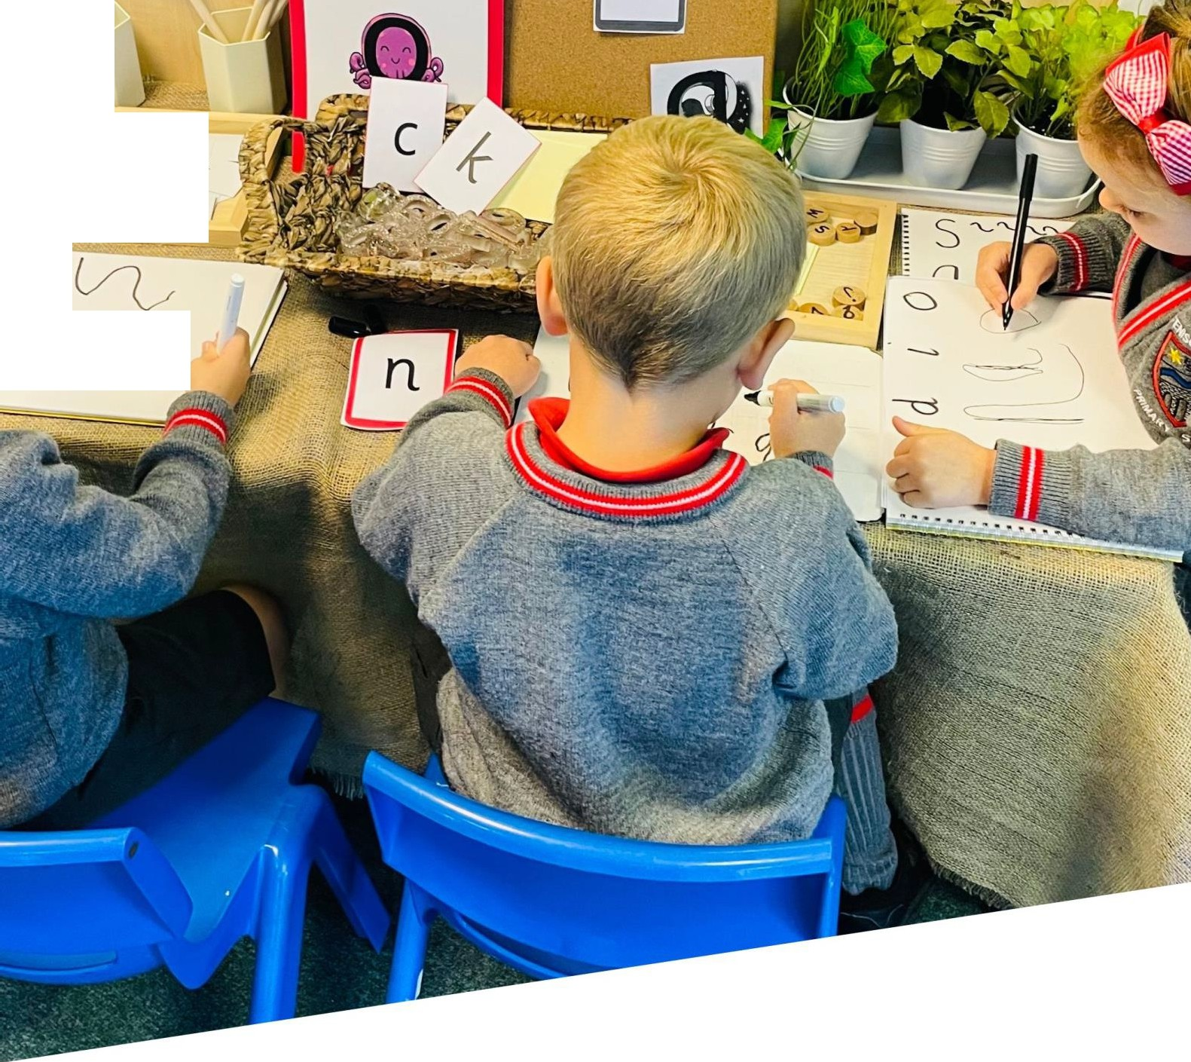

FENISCOWLES PRIMARY SCHOOL
'STRIVING FOR EXCELLENCE'

LOOKED AFTER CHILDREN (LAC)
AND PREVIOUSLY LOOKED AFTER CHILDREN (PLAC) POLICY

Revisions Written by : Carley Dootson
Date : 11/11/2025
Review date: 11/11/26

1. INTRODUCTION
Feniscowles Primary School is committed to ensuring that Looked After Children (LAC) and Previously Looked After Children (PLAC) receive the highest level of support to help them achieve their full potential. We recognise that children in care and those who have previously been in care may face unique challenges, including disrupted education, social and emotional difficulties, and additional safeguarding concerns.
This policy sets out the school’s responsibilities in line with the latest statutory guidance, including:
- THE DESIGNATED TEACHER FOR LOOKED-AFTER AND PREVIOUSLY LOOKED-AFTER CHILDREN (DfE, 2018)
- PROMOTING THE EDUCATION OF LOOKED-AFTER AND PREVIOUSLY LOOKED-AFTER CHILDREN (DfE, 2018)
- KEEPING CHILDREN SAFE IN EDUCATION (DfE, 2024)
- THE CHILDREN ACT 1989 & 2004
- THE CHILDREN AND FAMILIES ACT 2014
- WORKING TOGETHER TO SAFEGUARD CHILDREN (DfE, 2023)

This policy should be read in conjunction with the school’s Safeguarding, SEND, Behaviour, and Attendance policies.
2. DEFINITIONS

LOOKED AFTER CHILDREN (LAC)

Under the CHILDREN ACT 1989, a child is considered looked after by a local authority if they:
- Are under a care order (Section 31)
- Are under an interim care order (Section 38)
- Are voluntarily accommodated by a local authority (Section 20)
- Have been placed in secure accommodation or remanded to local authority care (Section 21)

This includes children in foster care, residential care, unaccompanied asylum-seeking children, and those placed for adoption.

Previously Looked After Children (PLAC)

A previously looked-after child is one who was previously in care but left due to one of the following legal orders:
- Adoption Order
- Special Guardianship Order (SGO)
- Child Arrangements Order

These children remain a priority group in education due to their previous experiences of care

Personal Education Plan (PEP)

A statutory document that forms part of a looked-after child’s care plan, setting out their educational needs, targets, and support strategies.

Virtual School Head (VSH)

A local authority officer responsible for:
- Overseeing the education of LAC
- Providing advice to schools on PLAC
- Managing Pupil Premium Plus (PP+) funding for LAC

We recognise the extended strategic role of the Virtual School Head in promoting the education of children with a social worker and children in kinship care, and will work with the VSH where appropriate when these children are on roll.
Blackburn with Darwen VSH Contact:
📞 01254 666434
📧 charlotte.hesketh@blackburn.gov.uk

3. RESPONSIBILITIES OF THE GOVERNING BODY
The Governing Board at Feniscowles Primary School will:
- Ensure all governors understand their legal responsibilities regarding LAC and PLAC.
- Appoint a Designated Teacher to oversee LAC and PLAC support.
- Monitor attainment, progress, attendance, and well-being of LAC and PLAC.
- Support the effective use of Pupil Premium Plus (PP+) funding.
- Ensure school policies reflect the needs of LAC and PLAC.
- Review this policy annually to ensure compliance with DfE guidance.
4. THE ROLE OF THE DESIGNATED TEACHER
Our Designated Teacher is our Deputy Head. In line with The Designated Teacher Regulations 2009 and DfE statutory guidance (2018), the Governing Body ensures that the Designated Teacher is an appropriately qualified and experienced member of staff and that they receive suitable training to fulfil their responsibilities in promoting the educational achievement of looked-after and previously looked-after children.

Miss Dootson
📧 deputyhead@feniscowles.blackburn.sch.uk
The Designated Teacher is responsible for coordinating the support for LAC and PLAC to achieve their full potential. This may, at times, including working with other professionals such as the SEND Coordinator or the virtual school educational psychologists.

KEY RESPONSIBILITIES OF THE DESIGNATED TEACHER

- Act as the key point of contact for LAC and PLAC.
- Write and oversee Personal Education Plans (PEPs) for LAC.
- Ensure pupil voice for LAC is regularly captured
- Manage online professional portals from the relevant local authorities associated with LAC children
- Attend termly PEP meetings
- Attend LAC review meetings
- Produce documentation which arises as a result of the meetings
- Attend other meetings as required for LAC and PLAC children such as strategy meetings or placement stability meetings, as required.
- Engage in placement review procedures
- Ensure pupil premium funding is used effectively for targeted interventions.
- Facilitate training for staff on the challenges faced by LAC and PLAC.
- Work closely with Virtual School Heads (VSHs) and social workers.
- Promote high aspirations and participation in extracurricular activities.
- Ensure student voice is heard in decision-making processes.
- Ensure LAC and PLAC pupil attainment and progress is carefully monitored.
- Support transitional handover information when children move between classes (or schools)
5. SUPPORT FOR LAC AND PLAC

ADDRESSING COMMON CHALLENGES

LAC and PLAC may experience:
- Attachment and trauma-related difficulties
- Gaps in learning due to school moves
- Higher risk of exclusion and mental health needs
- Low self-esteem and reduced engagement
The school will provide targeted academic and emotional support to address these barriers.
PERSONAL EDUCATION PLANS (PEPS)
- PEPs will be reviewed termly in collaboration with the virtual school, families, class staff, the social worker and the child themselves.
- Interventions will be monitored for effectiveness in closing attainment gaps.
- Pupil voice will be captured as part of the PEP process to ensure their viewpoints remain central to conversations about their lives.

PUPIL PREMIUM PLUS ( PP+) FUNDING
- PP+ funding will be used for academic interventions, mentoring, and wellbeing support.
- The impact of PP+ funding will be reviewed termly via the PEP document and the PEP meetings.
6. SAFEGUARDING AND BEHAVIOUR
- LAC and PLAC may be more vulnerable to bullying, exploitation, or exclusion.
- The Designated Safeguarding Lead (DSL) and Designated Teacher will work closely to ensure early intervention.
- If an LAC is at risk of exclusion, the school will consult the VSH before making a final decision (DfE guidance, 2023).

6b. SUSPENSION AND EXCLUSION
The latest DfE guidance (updated August 2024) stresses that:
- Suspension / exclusion of vulnerable groups, including LAC, should be used only when necessary and as a last resort
- Schools must inform the social worker and Virtual School Head without delay and work together on alternative provision where needed.
We will consider the suspension or exclusion of a looked-after or previously looked-after child only in exceptional circumstances and as a last resort, having considered reasonable adjustments and alternatives in line with DfE “Suspension and Permanent Exclusion” guidance (2024).
Where a LAC or PLAC is suspended or permanently excluded, the Headteacher will notify the child’s carers, social worker and the Virtual School Head without delay and work with the local authority to secure appropriate provision from the first day where practicable.

7. CONFIDENTIALITY AND INFORMATION SHARING
- Information about LAC and PLAC will only be shared on a need-to-know basis.
- The PEP meeting will determine what information can be shared with who.
8. TRAINING AND STAFF AWARENESS
- The Designated Teacher will receive training from the Virtual School.
- All staff will be briefed on LAC and PLAC needs as part of safeguarding training.
- Training areas include:
  - Attachment and trauma-informed approaches
  - Supporting children with disrupted education
  - Effective use of Pupil Premium Plus
  - Effective writing of SMART targets to support the children in reaching small-step goals
9. TRANSITION SUPPORT
- Dedicated transition planning will be in place for LAC and PLAC moving between year groups or schools.
- The Designated Teacher will ensure smooth information-sharing with receiving schools, and office staff as required.
- Additional visits and tailored transition support will be offered where necessary.
10. WORKING WITH EXTERNAL PARTNERS
Feniscowles Primary School will:
- Maintain close contact with carers, social workers, and Virtual School Heads.
- Inform the VSH immediately if an LAC is at risk of exclusion or persistent absence.
- Share PEPs and academic data with the child’s next school to ensure smooth transitions.
11. ADMISSIONS

Feniscowles Primary School’s Admissions Policy complies with the School Admissions Code (2021). Looked-after children and all previously looked-after children, including those who appear to have been in state care outside of England and ceased to be so as a result of being adopted, are given the highest priority in our oversubscription criteria.
12. POLICY MONITORING AND REVIEW
- This policy will be reviewed annually to align with DfE updates and best practice.
- The Designated Teacher and Governing Body will monitor its effectiveness.
- Regular data analysis and feedback from students and carers will inform improvements.

