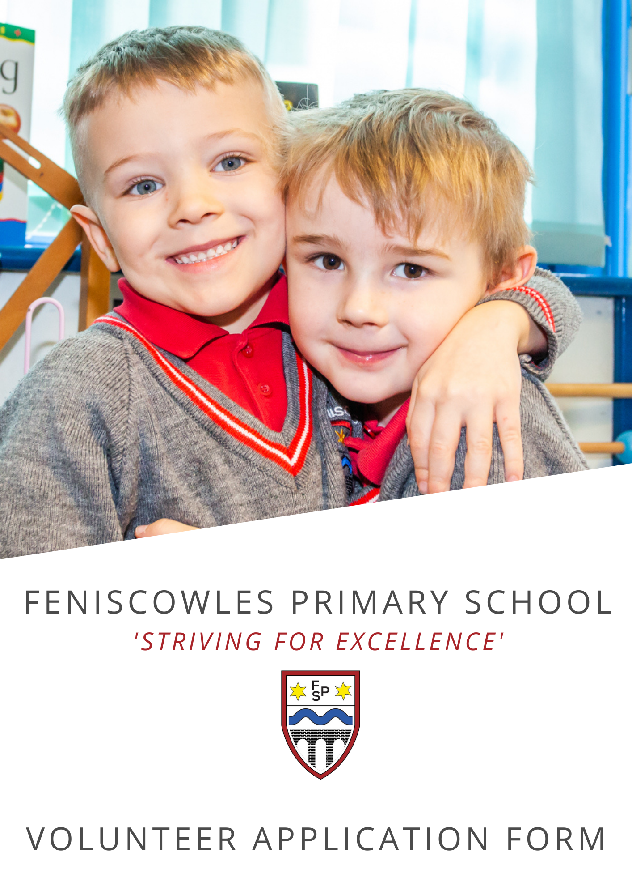
Application for Volunteering

Thank you for your interest in volunteering at our school. All information you provide will be confidential.
Volunteer role or type of duties applied for: __________________________________________________
Applicant Details
Surname
Forename(s)
Address
Telephone number (Day)
Telephone number (Eve)
Email address

Occupation (or previous occupation if retired):

Previous Employment
Employer | from | to | Job details

Gaps in employment
Any gaps in employment must be detailed below; you will have the opportunity to discuss in more detail if your application is progressed.

Date gap from |  | Date gap to |  | Reason/explanation for gap
Date gap from |  | Date gap to |  | Reason/explanation for gap
Date gap from |  | Date gap to |  | Reason/explanation for gap

Do you suffer from any disability or significant illness? Yes/No

If yes, please specify:

Have you ever been convicted of any criminal offence? Yes/No

If yes, please specify:

Have you previously worked with any other organisation as a volunteer? Yes/No
If yes, please give details below
Organisation:
Date:
Involvement:

Please state personal interests and activities:

Please state any relevant experience, qualifications or special skills you may have:

Please indicate when you would be available:

 | Monday | Tuesday | Wednesday | Thursday | Friday
Morning
Afternoon

References
Please give the names and addresses of two referees (not relatives) who have known you for at least two years (this is useful to gain an insight into your skills):

 | Referee 1 | Referee 2
Name:
Address:
Post code:
Tel. No:
Email:
In what capacity do you know them?

Please use the space below to add anything that you feel may support your application:

Signed: __________________________________________ Date: __________________

Before signing this document, prospective volunteers should be aware that they will be subject to Disclosure & Barring Service Checks.

Please return your application the School Business Manager; paper copies can be returned to the office or applications can be emailed to sbm@feniscowles.blackburn.sch.uk
For official use only

Date returned: Date of interview: References requested:
References received: DBS received:
Follow up action:

