**Recommended Revision Guides Year 2**

Reading: Comprehension

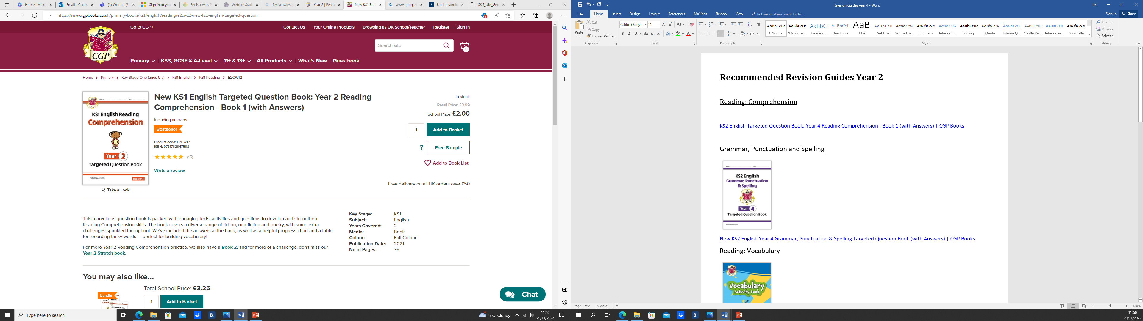

[New KS1 English Targeted Question Book: Year 2 Reading Comprehension - Book 1 (with Answers) | CGP Books](https://www.cgpbooks.co.uk/primary-books/ks1/english/reading/e2cw12-new-ks1-english-targeted-question)

Grammar, Punctuation and Spelling

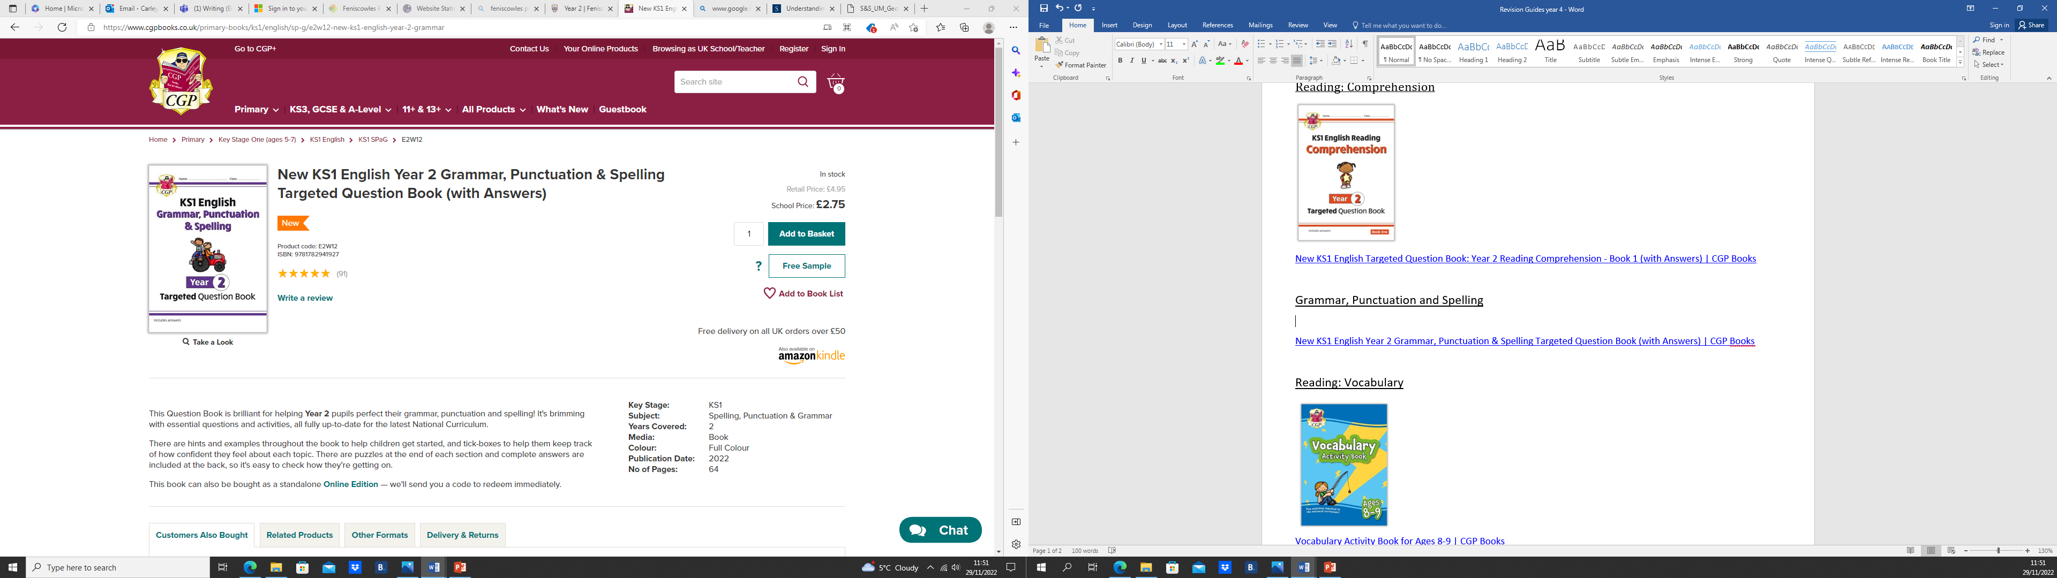

[New KS1 English Year 2 Grammar, Punctuation & Spelling Targeted Question Book (with Answers) | CGP Books](https://www.cgpbooks.co.uk/primary-books/ks1/english/sp-g/e2w12-new-ks1-english-year-2-grammar)

Reading: Spelling and Vocabulary

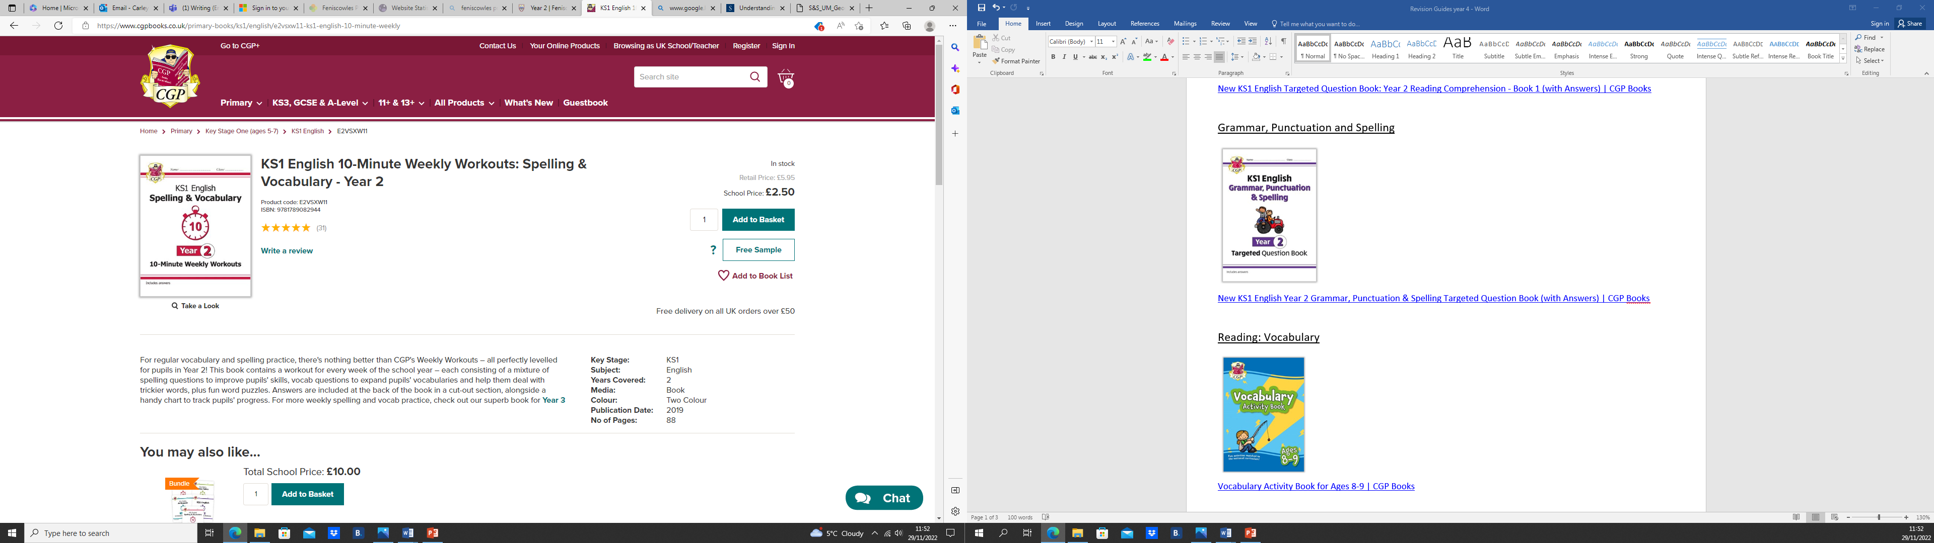

[KS1 English 10-Minute Weekly Workouts: Spelling & Vocabulary - Year 2 | CGP Books](https://www.cgpbooks.co.uk/primary-books/ks1/english/e2vsxw11-ks1-english-10-minute-weekly)

Reading: Vocabulary

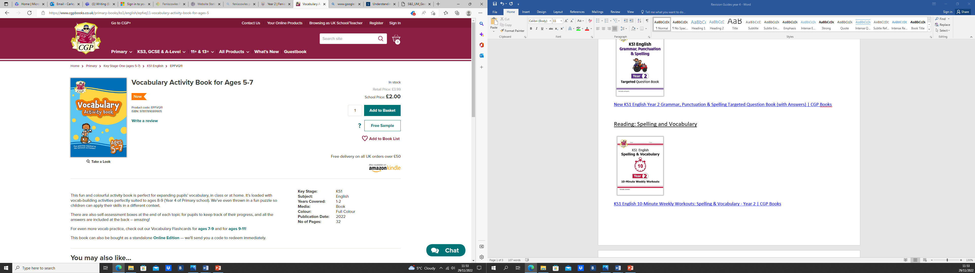

[Vocabulary Activity Book for Ages 5-7 | CGP Books](https://www.cgpbooks.co.uk/primary-books/ks1/english/epfvq11-vocabulary-activity-book-for-ages-5)

Maths: Mixed topics (Will help prepare for year 2 SATs)

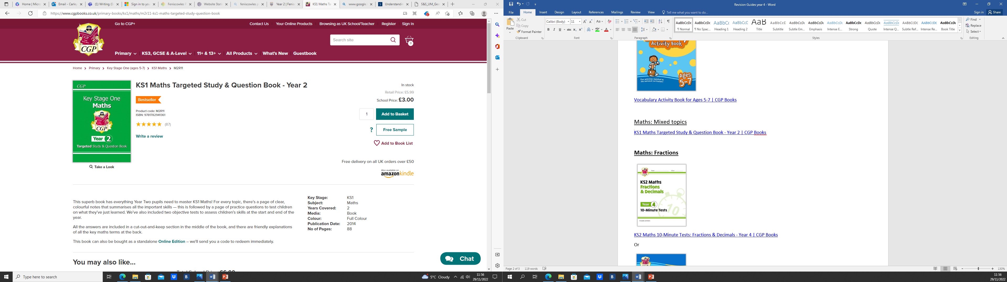

[KS1 Maths Targeted Study & Question Book - Year 2 | CGP Books](https://www.cgpbooks.co.uk/primary-books/ks1/maths/m2r11-ks1-maths-targeted-study-question-book)

**Maths: Fractions**

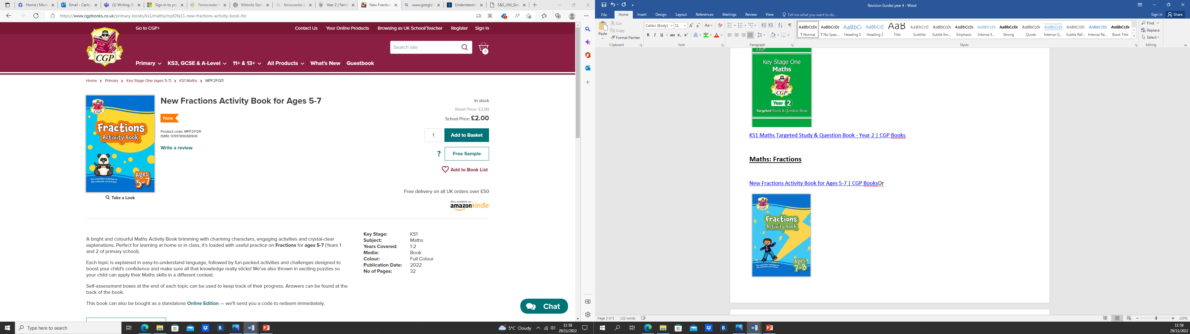

[New Fractions Activity Book for Ages 5-7 | CGP Books](https://www.cgpbooks.co.uk/primary-books/ks1/maths/mpf2fq11-new-fractions-activity-book-for)

**Maths: Measures – time**

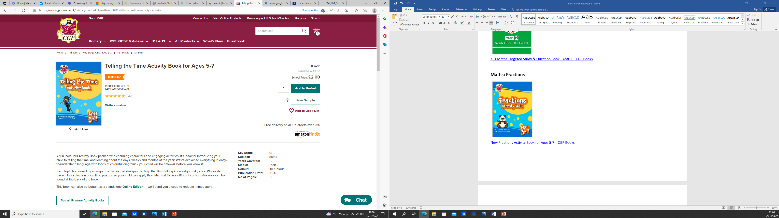

[Telling the Time Activity Book for Ages 5-7 | CGP Books](https://www.cgpbooks.co.uk/primary-books/ks1/maths/mpfti11-telling-the-time-activity-book-for)